# **Hafiz Kunwar Muhammad Ahmad**

# **DCCN Lab Terminal**

# **FA20-BSE-064 (B)**

**Q1 Packet Tracer Commands**

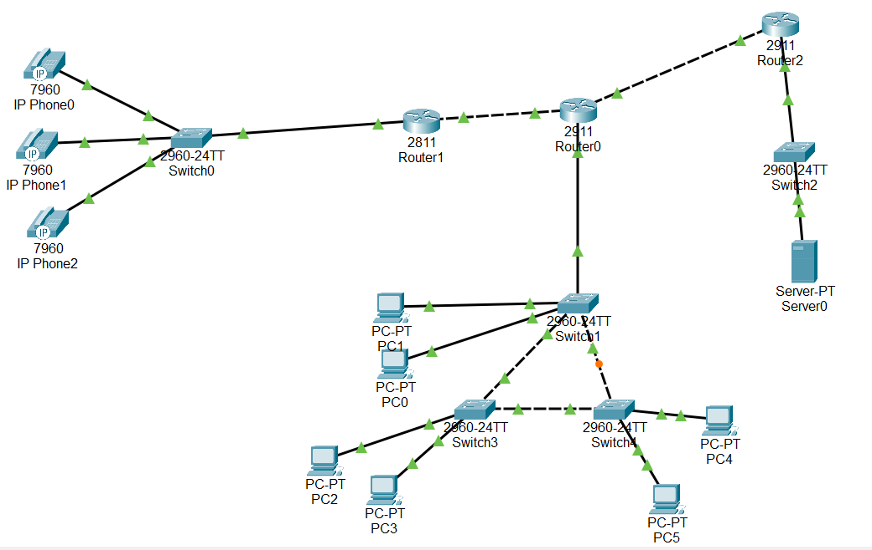 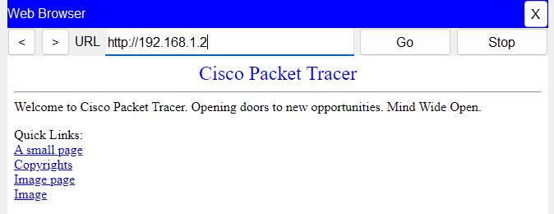 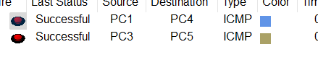

**Routers Config:**

**Router2**

Router>en

Router#conf t

Enter configuration commands, one per line. End with CNTL/Z.

Router(config)#int

Router(config)#interface fa

Router(config)#interface gi

Router(config)#interface gigabitEthernet 0/1

Router(config-if)#ip add

Router(config-if)#ip address 192.168.1.1 255.255.255.0

Router(config-if)#no shut

Router(config-if)#

%LINK-5-CHANGED: Interface GigabitEthernet0/1, changed state to up

%LINEPROTO-5-UPDOWN: Line protocol on Interface GigabitEthernet0/1, changed state to up

exit

Router(config)#ip dhcp pool A

Router(dhcp-config)#ne

Router(dhcp-config)#network 192.168.1.0 255.255.255.0

Router(dhcp-config)#def

Router(dhcp-config)#default-router 192.168.1.1

Router(dhcp-config)#exit

Router(config)#interface gigabitEthernet 0/0

Router(config-if)#ip add

Router(config-if)#ip address 192.168.2.0 255.255.255.0

Bad mask /24 for address 192.168.2.0

Router(config-if)#exit

Router(config)#exit

Router#

%SYS-5-CONFIG_I: Configured from console by console

Router#conf t

Enter configuration commands, one per line. End with CNTL/Z.

Router(config)#interface gigabitEthernet 0/0

Router(config-if)#ip address 192.168.2.1 255.255.255.0

Router(config-if)#exit

Router(config)#no shut

^

% Invalid input detected at '^' marker.

Router(config)#interface gigabitEthernet 0/0

Router(config-if)#no shut

Router(config)#router rip

Router(config-router)#ne

% Incomplete command.

Router(config-router)#ne

Router(config-router)#network 192.168.1.0

Router(config-router)#network 192.168.2.0

Router(config-router)#network 192.168.3.0

Router(config-router)#network 192.168.4.0

Router(config-router)#network 192.168.5.0

Router(config-router)#exit

Router(config)#

**Router0**

Router>en

Router#conf t

Enter configuration commands, one per line. End with CNTL/Z.

Router(config)#int

Router(config)#interface gi

Router(config)#interface gigabitEthernet 0/2

Router(config-if)#ip add

Router(config-if)#ip address 192.168.2.2 255.255.255.0

Router(config-if)#ip dhcp pool B

Router(dhcp-config)#net

Router(dhcp-config)#exit

Router(config)#interface gigabitEthernet 0/1

Router(config-if)#ip address 192.168.3.1 255.255.255.0

Router(config-if)#ip dhcp pool B

Router(dhcp-config)#exit

Router(config)#ip dhcp pool B

Router(dhcp-config)#net

Router(dhcp-config)#network 192.168.3.0 255.255.255.0

Router(dhcp-config)#def

Router(dhcp-config)#default-router 192.168.3.1

Router(dhcp-config)#dns

Router(dhcp-config)#dns-server 192.168.1.2

Router(dhcp-config)#exit

Router(config)#int

Router(config)#interface gi

Router(config)#interface gigabitEthernet 0/0

Router(config-if)#ip add

Router(config-if)#ip address 192.168.4.1 255.255.255.0

Router(config-if)#no shut

Router(config)#router rip

Router(config-router)#ne

% Incomplete command.

Router(config-router)#ne

Router(config-router)#network 192.168.1.0

Router(config-router)#network 192.168.2.0

Router(config-router)#network 192.168.3.0

Router(config-router)#network 192.168.4.0

Router(config-router)#network 192.168.5.0

Router(config-router)#exit

Router(config)#

**Router1**

Router>en

Router#conf t

Enter configuration commands, one per line. End with CNTL/Z.

Router(config)#int

Router(config)#interface fa

Router(config)#interface fastEthernet 0/0

Router(config-if)#ip add

Router(config-if)#ip address 192.168.4.2 255.255.255.0

Router(config-if)#no shut

Router(config)#interface fastEthernet 0/1

Router(config-if)#ip address 192.168.5.1 255.255.255.0

Router(config-if)#no shut

Router(config)#router rip

Router(config-router)#ne

% Incomplete command.

Router(config-router)#ne

Router(config-router)#network 192.168.1.0

Router(config-router)#network 192.168.2.0

Router(config-router)#network 192.168.3.0

Router(config-router)#network 192.168.4.0

Router(config-router)#network 192.168.5.0

Router(config-router)#exit

Router(config)#

**Router1 (VOIP)**

Router(config)#ip dhcp pool voice

Router(dhcp-config)#ne

Router(dhcp-config)#network 192.168.5.0 255.255.255.0

Router(dhcp-config)#def

Router(dhcp-config)#default-router 192.168.5.1

Router(dhcp-config)#option 150 ip 192.168.5.1

Router(config)#telephony-service

Router(config-telephony)#max-d

Router(config-telephony)#max-dn 5

Router(config-telephony)#max-e

Router(config-telephony)#max-ephones 5

Router(config-telephony)#ip s

Router(config-telephony)#ip source-address 192.168.5.1 port 2000

Router(config-telephony)#auto a

Router(config-telephony)#auto assign 1 to 5

After Switch Conf (Assigning Phone Numbers):

**Switch0 (VOIP)**

Switch>en

Switch#conf t

Enter configuration commands, one per line. End with CNTL/Z.

Switch(config)#int

Switch(config)#interface range fa0/2 - fa0/4

Switch(config-if-range)#sw

Switch(config-if-range)#switchport m

Switch(config-if-range)#switchport mode a

Switch(config-if-range)#switchport mode access

Switch(config-if-range)#sw

Switch(config-if-range)#switchport vo

Switch(config-if-range)#switchport voice v

Switch(config-if-range)#switchport voice vlan 1

Switch(config-if-range)#exit

**Switches Config for VTP:**

**Switch1 (VTP)**

Switch>en

Switch#conf t

Enter configuration commands, one per line. End with CNTL/Z.

Switch(config)#vtp domain Kunwar

Changing VTP domain name from NULL to Kunwar

Switch#

Switch#conf t

Enter configuration commands, one per line. End with CNTL/Z.

Switch(config)#inte

Switch(config)#interface ra

Switch(config)#interface range fa0/2 - fa03

^

% Invalid input detected at '^' marker.

Switch(config)#interface range fa0/2 - fa0/3

Switch(config-if-range)#sw

Switch(config-if-range)#switchport mo

Switch(config-if-range)#switchport mode tr

Switch(config-if-range)#switchport mode trunk

Switch(config-if-range)#

%LINEPROTO-5-UPDOWN: Line protocol on Interface FastEthernet0/2, changed state to down

%LINEPROTO-5-UPDOWN: Line protocol on Interface FastEthernet0/2, changed state to up

%LINEPROTO-5-UPDOWN: Line protocol on Interface FastEthernet0/3, changed state to down

%LINEPROTO-5-UPDOWN: Line protocol on Interface FastEthernet0/3, changed state to up

exit

Switch(config)#exit

Switch#

%SYS-5-CONFIG_I: Configured from console by console

show vtp status

VTP Version capable : 1 to 2

VTP version running : 1

VTP Domain Name : Kunwar

VTP Pruning Mode : Disabled

VTP Traps Generation : Disabled

Device ID : 0002.17A9.C200

Configuration last modified by 0.0.0.0 at 0-0-00 00:00:00

Local updater ID is 0.0.0.0 (no valid interface found)

Feature VLAN :

--------------

VTP Operating Mode : Server

Maximum VLANs supported locally : 255

Number of existing VLANs : 5

Configuration Revision : 0

MD5 digest : 0xD6 0xE5 0x96 0x9D 0x2F 0xB9 0x7B 0x3D

0x61 0xCC 0x41 0x94 0x5E 0x23 0x1A 0x84

Switch#show vtp status

VTP Version capable : 1 to 2

VTP version running : 1

VTP Domain Name : Kunwar

VTP Pruning Mode : Disabled

VTP Traps Generation : Disabled

Device ID : 0002.17A9.C200

**Switch3**

Switch#conf t

Enter configuration commands, one per line. End with CNTL/Z.

Switch(config)#int

Switch(config)#interface rang

Switch(config)#interface range fa0/1 - fa0/2

Switch(config-if-range)#sw

Switch(config-if-range)#switchport mo

Switch(config-if-range)#switchport mode tr

Switch(config-if-range)#switchport mode trunk

Switch(config-if-range)#

%LINEPROTO-5-UPDOWN: Line protocol on Interface FastEthernet0/2, changed state to down

%LINEPROTO-5-UPDOWN: Line protocol on Interface FastEthernet0/2, changed state to up

**Switch4**

Switch#conf t

Enter configuration commands, one per line. End with CNTL/Z.

Switch(config)#inte

Switch(config)#interface ran

Switch(config)#interface range fa0/1 -fa0/2

Switch(config-if-range)#sw

Switch(config-if-range)#switchport m

Switch(config-if-range)#switchport mode t

Switch(config-if-range)#switchport mode trunk

Switch(config-if-range)#exit

Switch(config)#exit